**Project Report**

The aims of the report are (i) to present the work to a wider audience which is unfamiliar with the project, (ii) to provide a written record for future reference by users of your software and further developers of your work, and (iii) to demonstrate the student's skills in writing and structuring a report.

Remember that, apart from seeing a brief demonstration of your software, the only thing that the external examiner has to judge your project is the dissertation describing it.

Every effort should be made to provide a professional, quality description of the work. All reports should be printed and securely bound.

If the project involved joint work with other people, there should be a section of the project report setting out as clearly as possible which parts the student did and did not do.

The final size of the dissertation tends to vary from 25 to 50 pages of main text (single spaced and printed single sided). About 25 is minimum. As well as the main text you should have appendices (in electronic form only) showing any additional material. The general arrangement of the report should be as follows:

* Title Page (Project Title, Author, Name of Degree & University, Supervisor, Date)
* Executive Summary of Project (1 Page)
* Declaration: signed by you (1 page): *"I declare that the special study described in this dissertation has been carried out and the dissertation composed by me, and that the dissertation has not been accepted in fulfilment of the requirements of any other degree or professional qualification."*
* Certificate, signed by your supervisor (1 page): *"I certify that (your full name) has satisfied the conditions of the Ordinance and Regulations and is qualified to submit this dissertation in application for the degree of Master of Science."*
* Acknowledgements
* Table of Contents
* List of Figures
* Main body (typically 5 or 6 chapters)
* References

The report should be written in a formal style. All pages should be numbered, the first page of chapter 1 being page 1. All references should be cited in the main body of the report. The report should demonstrate that the student has used appropriate tools to support the development process and that verification and validation have been applied at all stages.

The main body of the report should address the following:

* **Introduction: An explanation of the problem and the objectives of the project.**

1. Introduction

Niger state polytechnic, Zungeru is a tertiary institution with 2 colleges (college of Science and Technology (CST) and College of Administrative and Business Studies (CABS)) each college has 3 schools (Environmental studies (SES), Engineering Technology (SET), Administrative Studies (SAS), General Studies (SGS), Business Studies (SBS), and Natural and Applied Sciences (SNAS)) each school has various departments and about 35 programmes form 17 departments in total. Result computation starts from departmental level, the department collect the approved list of students and courses from the Academic Planning Unit, all exams scores are submitted to the departmental coordinators by various course lecturers, then the scores are computed against each student and the responding courses they offered. After computation the result is submitted to the exams and records unit in broad sheet format ready to be presented to the academic board, the broad sheet comprises analysis showing all courses offered, code, unit, grades, total, mean, standard deviation and percentage pass, it also include the result summary, showing total number of students in class, number of students that passed, number of students with Carry Over, Number of students absent with Excuse, and number of students advise to withdraw.

In view of the above new (automated) system will comprise of five user access role as:

* System manager: This user controls all user accounts, manage personal records of students and courses (add, update and view)
* Department Coordinator: This user manage student scores (import/input/add student exam scores, consider/edit/update) score and allocate courses to a staff in a specific department
* Student: This user will only have access to view their individual result as a whole or in in semester basis.
* Teaching staff: this user can import and view student exam scores of only course allocated to them by the departmental coordinator.
* Exams and Records: This user can only view student personal information, courses, and broad sheet result of all departments

All of the users listed above will have different view when given access to the system through a login page process.

1.1 Aim and Objectives

The aim of the project is to develop a web-based system as an automation to the existing manual process of computing students’ examination results in Niger state Polytechnic, as the existing system is prone to errors and waste of time and resources like paper. The objectives are as follows:

* To develop a web based system with five (5) user role each with different user view as describe above.
* To Keep track of up-to-date records of the entire students in polytechnic
* Support Registration, data upload, queries to the system, generate broad sheet report and student result analysis for academic board decisions making with user-friendly interfaces for easy interaction
* Gather information about user needs of a vegan
* Design a medium fidelity prototype
* Develop and design a web application in PHP, using MySQL, HTML, CSS and JavaScript.
* Test the application for any dysfunctionality

1.2. Organisation of the Report

In this report the development of online communities and their food sharing cultures is firstly considered (Section 2). Then the methodology is stated and justified (Section 3). In the next six sections the parts of the methodology are analysed. The section 4 contains all the means that helped gathering the requirements.

Next, the initial design process is described and evaluated (section 5). Then the implementation of the product and the technologies which were used are analysed (section 6), as well as the testing results. After that, the final product is described (section 7) and evaluated (section 8).

Finally, we summarise the project and identify further directions it could take in Section 10.

* **Background: A (usually brief) review of relevant literature and products to establish the context of the project.**

2. Background

The use of computers systems to process information is imperative and desirable as it would enable computing of students progress, better access to students' records (personal, and courses), updating student records keeping track of passed and failed courses (performance). The support of storing course information (course codes, course title, course credit units and grade points for the purpose of computing GPA with automation is required.[3]

Creating and organizing information in a useful manner is known as data processing. (Udeze, 2017) Explain how the manual method of computing students result prompt to lots of errors in most tertiary institutions in Nigeria.

**2.1 Similar work/application**

A necessary stage for a successful product was to implement an in-depth research to investigate similar web applications for exclusively vegan recipes.

It has to be considered that the majority of the products didn’t have only vegan recipes. However, some of them had extra options to filter the results by the dietary options. In addition, many of them didn’t provide nutrition information of the recipes, which is very important for the vegan way of living, as healthy diet is the first goal to achieve. Finally, only a few of them had suggestions of the ingredients that were available for each recipe.

Three of these web applications will be briefly analysed bellow.

2.1.1 Result Analysis and management system

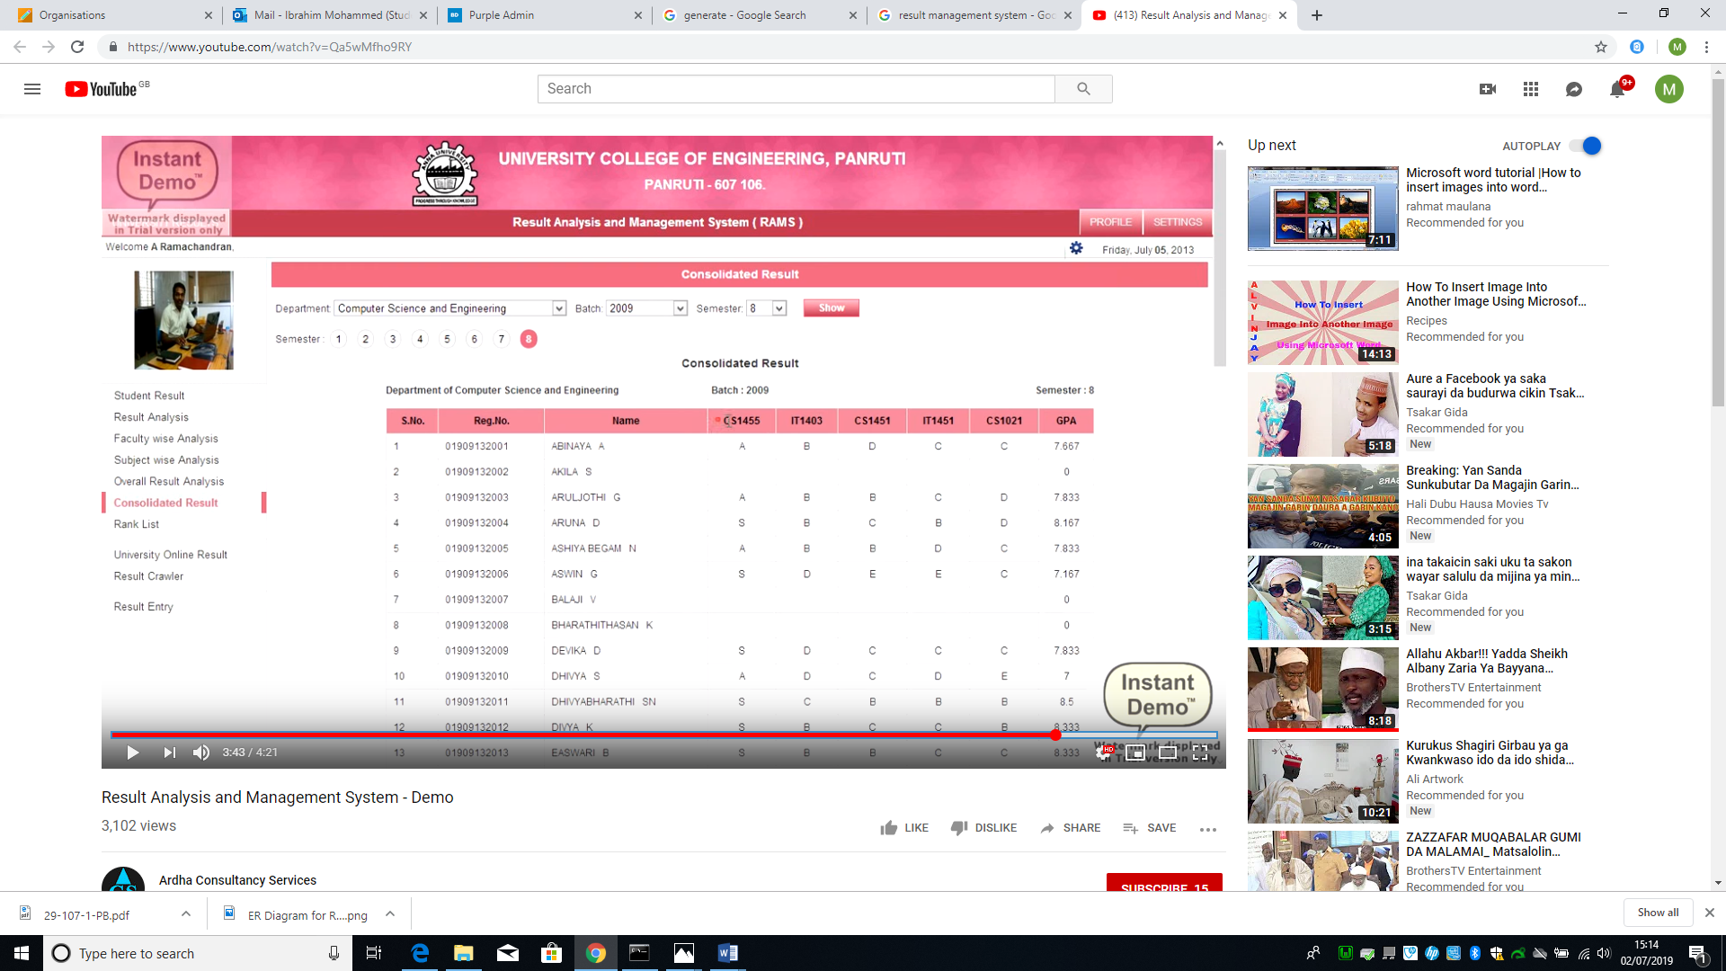Figure 1. Screenshot from [YouTube](https://www.youtube.com/watch?v=Qa5wMfho9RY)

About the figure above

Result Computation System (RCS) is an automated platform used in managing result for all categories of students in a friendly and interactive manner. Nigerian tertiary institutions follows the trend in Information and Communication Technologies in transforming their record keeping and information management operations. RCS is currently an information systems that readily attracts the attention of many tertiary institutions in Nigeria. Most of the Students’ RCS are traditional and standalone which has few or basic elements of a standard RMS. Most of the students RMS are not web based and others do not integrate well with the other information system in the Universities.[1]

2.1.2. Online Result management system

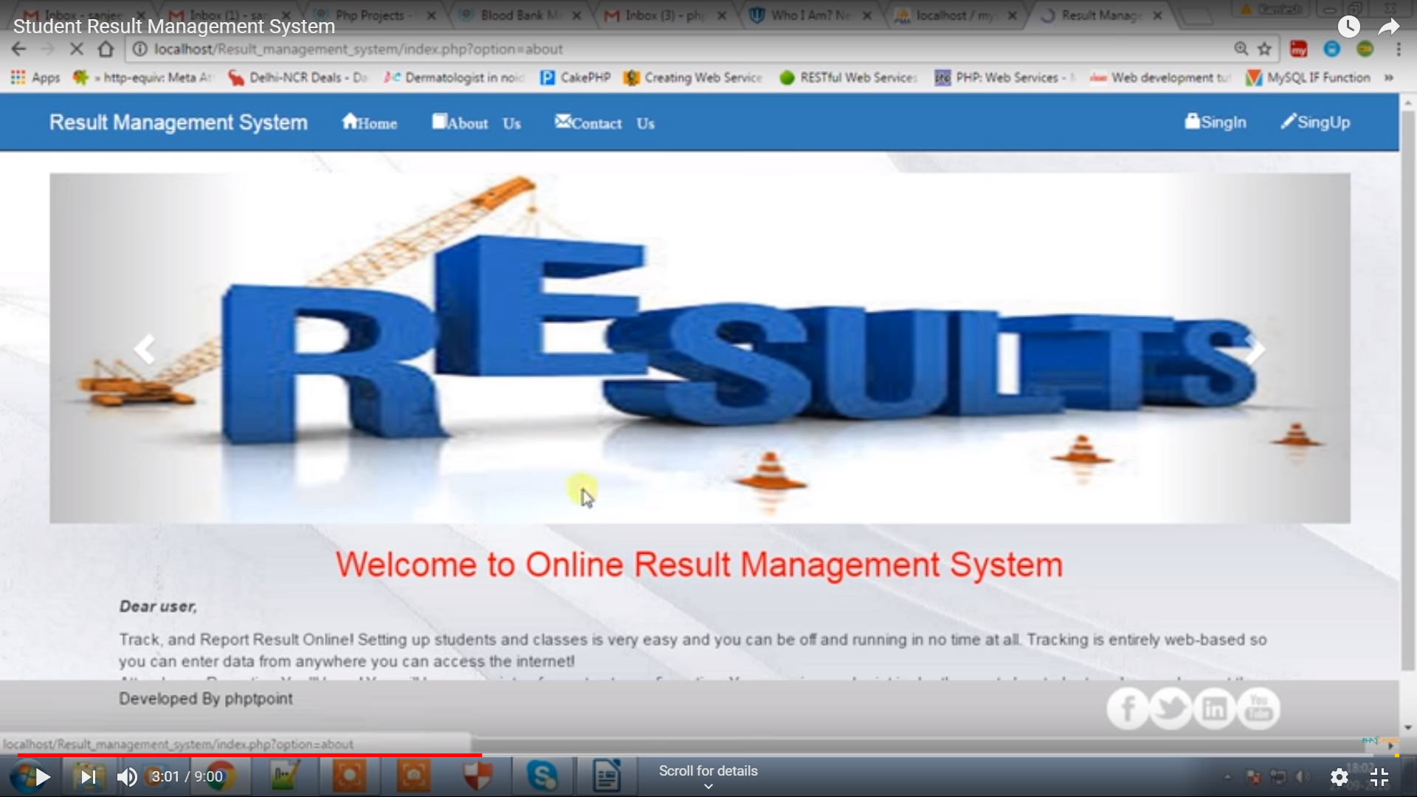Figure 2. Screenshot from the [YouTube](https://www.youtube.com/watch?v=NCDLuboYNZQ)

About the figure above

Student result analysis is an online application used to analyse, store and keep track of student data and compute the mark analysis process in an educational institution, it enable the view of individual student’s result, automated computation of results from various departments. The use of computation systems that has it capabilities beyond result computation which is not so much in use. Tertiary institutions today compute student result analysis manually which consume lots of time and effort. A system that does analysis of student result is required as it will aid decision-making and taking in tertiary institutions. [2]

In view of the above related work it is clear that the the requirement to have an online Result computation system in Niger state Polytechnic, Zungeru, Nigeria is important. In the institution, Students result are computed every semester from the summation of CA and Exam score of each course taken by students, given each student grades, GP, CGPA and remark. This is presented as broadsheet with analysis. The computation of result is completely manual.

This project is to create a web-based Result Computation System that would allow teachers submit/input/import students Exam score, the system will compute the scores, generate a broadsheet and provide analysis of the results on a semester basis. The students would be able to view their result through their profiles.

This project will considered security as an utmost priority, providing a login form for authentication of users and registration form to register student and courses offered.

References

*1. Akpasam J. E., Simeon O., Afolayan J. J. (2017). Development of Students Result Management System: A case study of University of Uyo. Mathematical and Software Engineering, Vol. 3, No. 1, 26-42.*

*2. Ashwin M., Jugal P., Aditya M. (2018). Student Result Analysis System. International Research Journal of Engineering and Technology (IRJET), vol.5, e-ISSN: 2895 -0056*

*3. UDEZE, C. L., UMOREN, P. U., OHERI, H. E., & ATTAH H. H. (2017) Automated Students' Results Management Information System (SRMIS), Journal of Multidisciplinary Engineering Science and Technology (JMEST) Vol. 4, ISSN: 2458-9403,*

* **Requirements specification: A specification of the problem and an explanation of how the student arrived at this specification. An initial work schedule including an overall project plan with time-scales, deliverables and resources.**

3. Requirement Specification

3.1 A specification of the problem

With the current trend in technology, Niger state polytechnic as a tertiary institution should have an automated means of computing student results, to enable it meet certain educational standard and requirements, an automation is required to eliminates errors in computation and reduce miss-use of resources and bring ease.

Currently the school is operating a manual system, every department computes students result in different formats in an un-centralised manner, some departments uses format such as excel sheet while some are completely paper based.

In previous years, a partial automated system of result computation has been introduced by the school authority to various departments that was used as a standalone system to enable departmental coordinators enter exam scores in text file then use the command line environment to manipulate the text files to generate a computed result, the system was not friendly, requires memorising commands and it takes a lot of time to arrange the scores in a text file and does not support editing, it is developed using Fortran. Yet with the introduction of the so called automated system every operation still seems manual, errors recorded are even more compared to the use of excel files, which has led to many departmental coordinators to dump it. Even after result is generated still analysis is done manually, given inaccurate results. It take the coordinator so many days to compute a single class, they become stressed up and sometimes frustrated as so many time is required. This problems lead to delay in producing result for student and also delay in taking and making decision.

If this problems are not taking care of it would lead to an educational degradation and inconsistent result generated continuously, although many institutions have similar issues or problems but they have often used different methods to solve the problems, but I feel developing a web based system that will be used by all department in a centralised manner, enabling result computation, adding and editing student exams score, generating broad sheet result with analysis, allowing individual student see their result on time from the comfort of their homes and also enable timely decision taking and making will make more significant difference from the methods previously used.

Finally I decided to develop the proposed system based on the problem statements stated above, leading to the requirement stated below.

3.2 Methodology

The methodology explain how we arrived on the specifications consisting of stages (gathering requirements, online review, Prototyping, evaluate it, implement it, evaluate)

3.2.1. Gathering Requirements

In order to gather the requirements for the web application a heuristic evaluation was conducted on a similar web application.

The heuristic evaluation was based on the Jakob Nielsen’s ten usability heuristics. Heuristic evaluation (Nielsen and Molich, 1990; Nielsen 1994) is a usability engineering method for finding the usability problems in a user interface design. Heuristic evaluation involves having a small set of evaluators examine the interface and judge its compliance with recognized usability principles (the "heuristics"). The main advantages of this method of evaluation are that it’s very easy to do it, and at the same time it doesn’t take too long to complete it. On the other hand, according to Jakob Nielsen there is a need of more than one evaluator in order to conduct the evaluation with valid results.

The heuristic evaluation was based on the Jakob Nielsen’s ten usability heuristics. Heuristic evaluation (Nielsen and Molich, 1990; Nielsen 1994) is a usability engineering method for finding the usability problems in a user interface design. Heuristic evaluation involves having a small set of evaluators examine the interface and judge its compliance with recognized usability principles (the "heuristics"). The main advantages of this method of evaluation are that it’s very easy to do it, and at the same time it doesn’t take too long to complete it. On the other hand, according to Jakob Nielsen there is a need of more than one evaluator in order to conduct the evaluation with valid results.

3.2.2. Online Review

An online review was conducted, in order to find some ideas for the personas that will be represent the future user. Two personas were created according to the main characteristics of the vegan communities on the internet. The research was focused mostly on the social media networks and more specifically on Facebook. As a member of some vegan groups it was easy to gather some main information for the personas, such as hobbies, daily routines, etc.

Personas were first introduced in 1998 by Alan Cooper2. Personas are fictitious characters that represent the potential users of the product. They are very beneficial for the design process, as they help the designers concentrate and understand what the users will feel when they use the product.

Furthermore, an alternative to the personas are the actors. However, the actors can be either humans or external systems. They represent the role of a specific user class that will be performed during the interaction with the product at a specific time. The main reason why the personas were chosen is that personas are more realistic; for example, personas can describe two different types of users, yet the actors are only limited to one type.

3.2.3 Prototyping

Having gathered all the requirements above, the medium fidelity was designed The personas and the scenarios were very important in order to have some first ideas about the web application and create a medium fidelity prototype, so it can be tested form a focus group.

The prototype was designed using Photoshop for the sketches and InVision App tool. Photoshop was used for the sketches as it is very simple but it has many features. Photoshop is a digital imaging software3 which currently is considered the best in the market. InVision4 is a web based prototyping tool and at the moment it’s the world's leading prototyping, collaboration & workflow platform. It’s easy for quick interactive prototypes and it offers the opportunity to share it by generating a link. Like any other similar tool, it is required to have the designs or sketches, in order to add them to the dashboard of the tool and start the interaction.

There are many similar products, but the biggest competitor is Marvel App, which has many good reviews too. These two apps are very similar and very easy to use. Invision was chosen because it has a more convenient layout and it has been previously used for assignment projects, so it was more familiar.

For the prototype, the green colour was chosen, as it refers to vegan and environmental topics. Green is a colour that is connected with the environment and the nature.

3.2.4 Evaluation

Although the design of the prototype was based on the previous research, there was a need for some extra opinions about the decisions for the features, the layout and the colours. For that reason, a focus group conducted and the details of the process will be analysed below. Examples of the focus group questions can be found in the appendices (II).

Focus group is a small group of people who are gathered in order to discuss about a specific topic of interest. Typically it involves five to seven participants (Krueger, 1994) who express their thoughts and preferences on the topic. They provide a wider range of viewpoint because during the discussion they might agree or disagree and that can be very informative.

An alternative method would be the interviews, but it would take more time to finish approximately five interviews and the results could be less helpful. For example, if the interviewees are not talkative or if something happen during the interview that makes them feel awkward, then the interview will fail (as Lazar et al OR Lazar, Feng & Hochheiser say). On the other hand, more time with each participant could give more detailed results but that is not necessarily a positive aspect.

The results of the focus group were analysed using content analysis. It is the most common method for analysing the focus group data.

In order to ensure that the evaluation results would be credible and useful, the data were analysed systematically. Although there are various definitions of content analysis, Stemler (2001) stated that it is a “systematic, replicable technique for compressing many words of text into fewer content categories based on explicit rules of coding”. Also, Holsti (1969) said that content analysis is “any technique for making inferences by objectively and systematically identifying specified characteristics of messages” (Lazar, Feng & Hochheiser).

First, the audio file was transformed into written text format and organised into categories, along with the notes that were kept during the session. Then, the text was read again, in order to double check that all the important data are described.

Evaluate

The final evaluation of the web application was conducted using an online questionnaire targeted mostly to vegan users. The aim of the questions was to the questionnaire (see appendix III) was first revised and approved by the ethical committee of the University of Dundee. Then, it was transferred to an online survey tool – SurveyMonkey5 – in order to have the appropriate layout and administered to the participants. The questionnaire was open to participants for one week.

Moreover, the Nasa TLX questionnaire (see appendix IV) was used. The Nasa TLX was not targeted to vegans, as it was only used to measure the effort that the users put during the tasks that they had to complete.

3.2.5 Implementation

3.3 Project plan

The initial time management plan was very simple and included a table with two columns, one for the tasks and one for the duration of each task. Some of the tasks were supposed to happen at the same time and that is noted next to the respective tasks.

|  |  |
| --- | --- |
| Activities | Time (Duration) |

* Design: This should include the design method, design process and outcome. Design decisions and trade-offs should be described e.g. when selecting algorithms, data structures and implementation environments or when designing for usability.
* Implementation and Testing: A description of production, testing and debugging. A demonstration that the specification has been satisfied.
* Evaluation: You should carry out formal user evaluations and report on them.
* A description of the functionality and interfaces of the completed system.
* Appraisal: A critical appraisal of the project indicating the rationale for design/implementation decisions, lessons learnt during the course of the project and an evaluation (with hindsight) of the final product and the process of its production (including a review of the plan and any deviations from it). The project should be placed in a wider context and this could include the scientific, technical, commercial, social and ethical context.
* Summary and Conclusions.
* Recommendations for future work.

**Appendices**

The main body of the report should read as a self-contained document. Additional materials should be submitted electronically as appendices (hard copies are not required). These should include:

* the software and source code
* the user manual and/or technical manual as appropriate
* the minutes of meetings with your supervisor or others
* your ethics submission(s) and the Ethics committee's response(s)
* the poster for your demonstration

Any other important detailed information should also be included in appendices; the exact nature of these will depend on the kind of project that you have done, but will often include:

* details of requirements and design
* experimental results
* results of testing

As a general guide, the appendices should contain all of the detailed information about your project, in particular all information which might be useful to someone who wishes to use or extend your work in future. The appendices can be in separate files arranged appropriately in different folders; there is no need to compile them into a single document. Portable Document Format (PDF) should be used whenever possible.

If any paper or article arising from the project has been submitted for publication to a journal or conference, a copy of the submitted paper should be included as an appendix.

**Binding of report**

The two hard copies of the report should be securely bound. One way to do this is to use the spiral binding machine which will be available in Lab 5.

Security

To prevent CSRF you'll want to validate a one-time token, POST'ed and associated with the current session. Something like the following . . .

On the page where the user requests to delete a record:

**confirm.php**

<?php

 session_start();

 $token= md5(uniqid());

 $_SESSION['delete_customer_token']= $token;

 session_write_close();

?>

<html>

<body>

<form method="post" action="confirm_save.php">

 <input type="hidden" name="token" value="<?php echo $token; ?>" />

Do you really want to delete?

<input type="submit" value=" Yes " />

<input type="button" value=" No " onclick="history.go(-1);" />

</form>

</body>

</html>

Then when it comes to actually deleting the record:

**confirm_save.php**

<?php

 session_start();

 $token = $_SESSION['delete_customer_token'];

 unset($_SESSION['delete_customer_token']);

 session_write_close();

 if ($token && $_POST['token']==$token) {

   // delete the record

 } else {

   // log potential CSRF attack.

 }

?>

The token should be hard to guess, unique for each delete request, accepted via $_POST only and expire after a few minutes (expiration not shown in this example).

<https://resources.infosecinstitute.com/fixing-csrf-vulnerability-in-php-application/#gref>